Confirmation Session II

Purpose: General Survey of history, creeds, sacraments, and practices of the Episcopal Church.

Review:


Authority: Scripture, Reason, Tradition, and our Experience of God in this place.

Sacraments are outward and visible signs of an inward and spiritual grace, given by Christ as sure and certain means by which we receive that grace. In other words, a sacrament points us to the presence of Christ in the world.
The Seven Sacraments are Baptism, Confirmation, Eucharist, Marriage, Confession, Ordination, and the Anointing of the Sick

Baptism and the Eucharist are dominical (taught by Jesus) sacraments that Jesus commanded his disciples to continue, while the other five are sacramental rites taught by the church.

Eucharistic Beliefs

*In the celebration of the Eucharist, we are fed by the word and sacrament; scriptures are read, and we feast on Christ’s presence in bread and wine.

Liturgy (Public Offering) of The Word of God.

*Liturgy or public offering is structured in large and small ways as a call and response. The offering of God’s word calls us to respond with eucharistic thanksgiving.

In the beginning was the Word, and the Word was with God, and the Word was God. He was in the beginning with God. All things came into being through him, and without him not one thing came into being. What has come into being in him was life, and the life was the light of all people. The light shines in the darkness, and the darkness did not overcome it. John 1: 1-5

The Greek term for "word" is logos, meaning "ground," "speech," or "expectation." Not “word” as a part of speech. Not lexis “word” but logos “WORD”, the very ground of divine being, the breath of God, the presence of the holy in and through all things.

*Seasonal Acclamation (BCP Pgs. 323 & 355)

*Collect for Purity -Preparatory prayer for public worship reminiscent of Psalm 51 (BCP Pg 656). It has been used at the opening of the Anglican Eucharist since 1549.

Almighty God, to you all hearts are open, all desires known, and from you no secrets are hid: Cleanse the thoughts of our hearts by the inspiration of your Holy Spirit, that we may perfectly love you, and worthily magnify your holy Name; through Christ our Lord. Amen.

*Songs of Praise or of God’s Mercy

Gloria in Excelsis Dio “Glory to God in the Highest” which is inspired by the Gospel of Luke when the angels sang at Christ’s birth. (See Luke 2:13-14)
Kyrie eleison (Greek) Lord, have mercy.
Trisagion-the thrice-holy hymn “Holy God, Holy and Mighty, Holy Immortal One, Have mercy upon us.”

*The Collect of the Day BCP Traditional Pg. 159-210 Contemporary Pg. 211-261
A Collect is a prayer that brings together “collects,” the prayers of the gathered community. The “Collect of the Day” gathers the themes of the appointed scripture readings for the day and calls us to respond in celebration of Christ’s incarnation and how it can bear fruit in our lives.

*The Lessons & Sermon
Scripture is read from Old Testament, Psalms, Epistle, and Gospel.

The sermon is a response to the scripture. Its purpose is to draw us into the narrative of God’s love found in scripture and to help us find our place in that grand story.

The Creed(s)
Creed is from the Latin word Credo, meaning “I believe” or “I give my heart to.” The creeds are a concise summary of Christian belief, but they are more than that. They are what we, as followers of Christ, give our hearts to. “The heart here is a metaphor for the self at its deepest level-a level of self beneath thinking, willing, and feeling. To whom do you give your heart, yourself to? To whom do you commit yourself? Whom do you love? “Do you believe in me?” meant “Do you belove me?” (Speaking Christian: Why Christian Words Have Lost Their Meaning and Power and How They Can be Restored, Marcus J. Borg, Pg 118-120)
Short Creed-New Testament
For I handed on to you as of first importance what I in turn had received: that Christ died for our sins in accordance with the scriptures, and that he was buried, and that he was raised on the third day in accordance with the scriptures, and that he appeared to Cephas, then to the twelve. I Corinthians 15: 3-5
Nicene Creed
The Nicene Creed takes its name from the Council of Nicaea (325 CE.), where the question was debated: In what way was Jesus both God and Man? The Nicene Creed is used at the Eucharist.
Apostles Creed
The Apostles’ Creed was first known in its present form in about 400 CE. It is used at Baptism.
The Athanasian Creed (Historical Documents Book of Common Prayer, pp. 864-865
The Athanasian Creed (373 CE). Expounds orthodox Christian views of the Trinity and the Incarnation, warning that these beliefs are indispensable for salvation.
*The Prayers of the People (See BCP Pg. 359)
*Confession of Sin -Corporate and Individual Sins of commission and omission.
*The Peace
Shalom, “Peace”, means fullness, having everything to be wholly and happily yourself.
Shalom is….” fullness,” “Completeness.” So, it is well-being. It is prosperity: Not in a cheap make-a-profit-of possibility, but in a deep sense of my well-being, integrated with the well-being of all around me, human and nonhuman, and the earth on which our lives depend. Ellen Davis
So, when you are offering your gift at the altar, if you remember that your brother or sister has something against you, leave your gift there before the altar and go; first be reconciled to your brother or sister, and then come and offer your gift. Matthew 5: 23-24

Eucharist is a Greek word meaning thanksgiving. In this sacrament, we give thanks to God, offering God our gifts from what God has given us. The centerpiece of Holy Eucharist, or Communion, is called the “Great Thanksgiving” because, in Communion, we receive the real presence of Christ and respond with gratitude.

In the Eucharist, the outward and visible sign is bread and wine, and the inward and spiritual grace is the “real presence of Christ”.

The Holy Eucharist is the principal act of Christian worship on the Lord’s Day and other major feasts. Concerning the Service of the Church, BPC Pg 13. Also referred to as the Lord’s Supper, Holy Communion, Divine Liturgy, Mass, The Great Offering.

Thanksgiving: Practice and Way of Life.
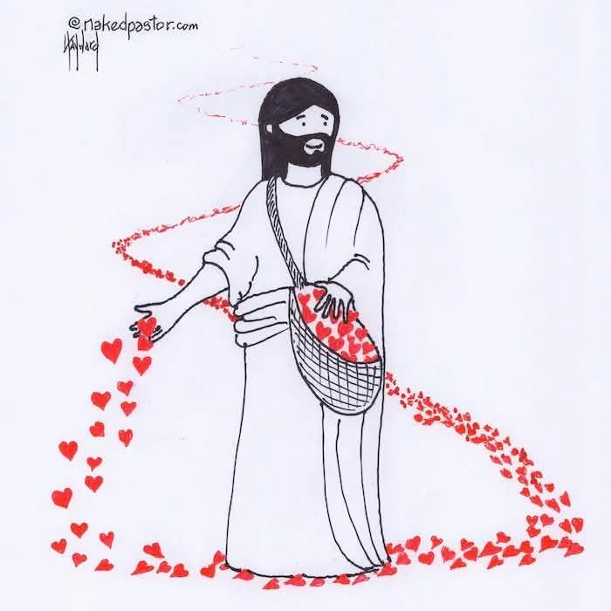

“If you are grateful, you’re not fearful, and if you’re not fearful, you’re not violent. If you are grateful, you act out of a sense of enough and not a sense of scarcity, and you are willing to share. If you are grateful, you are enjoying the differences between people, and you are respectful to everybody, and that changes this power pyramid under which we live.” Brother David Steindt-Rast

The Liturgy of the Table The Great Thanksgiving

The structure of the Eucharistic Celebration is based on events in which Jesus fed the multitudes, during which He received the offerings, expressed gratitude through blessing, broke the bread, and distributed it to those present.
See Matthew 14: 13-21; 15: 32-39; Mark 6: 30-44; 8: 1-9; Luke 9: 10-17 & John 6: 1-14

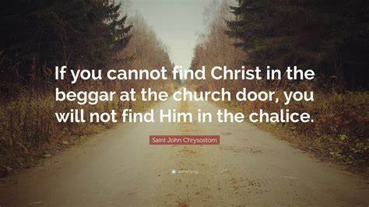
*Words of Institution
Do this for my Anamnesis “For the remembrance of me.” This is remembering in such a way as to participate in making the bread and wine “really real”. It is a vivid and active remembering of the life, death, and resurrection of Christ by which we are being re-membered or put back together again as the Body of Christ or the assembled community of faith.
*Note the opposite of anamnesis, “remembering” is amnesia, a disorienting loss of memory.

Concludes with a blessing and “being sent out to love and serve the Lord.”

Concerning the Sacrament of Confirmation
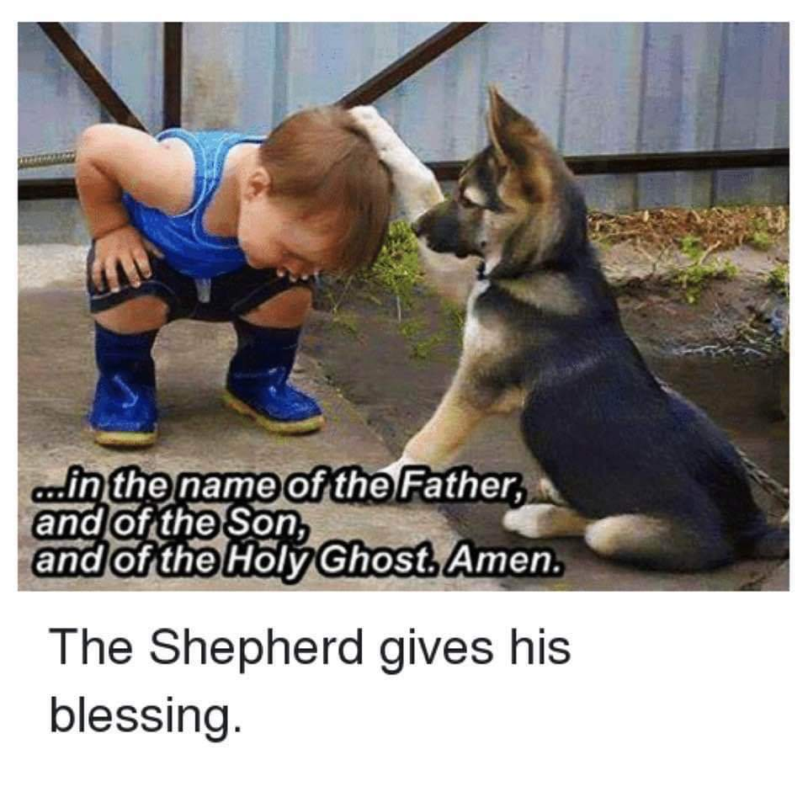
During Christian development, those baptized at an early age are expected, when they are ready and have been duly prepared, to make a mature public affirmation of their faith and commitment to the responsibilities of their Baptism and receive the laying on of hands by the bishop. Book of Common Prayer Pg. 412
Therefore, be eager to confirm your call and election, for if you do this, you will never stumble.
II Peter 1:10

Confirmation is from the Latin confirmare, meaning “to make firm”. Confirmation is the formal personal affirmation of vows of faith taken for one at baptism.

See Book of Common Prayer (BCP), Pg.415-417
In Confirmation, Reception, and Reaffirmation, the outward and visible sign is the laying on of hands by the bishop. In our case, the Shepherd gives her blessing. The inward and spiritual grace is the Holy Spirit, who empowers and strengthens.

