Confirmation Session III

Purpose: General Survey of History, Creeds, Sacraments, and Practices of the Episcopal Church.
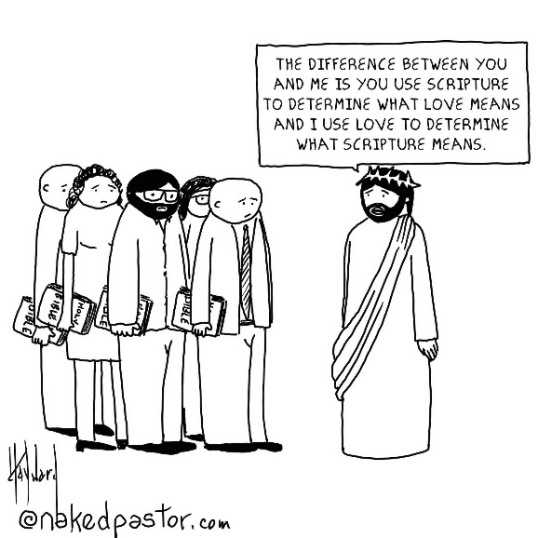
Review:

Sacraments are visible signs of inward grace, given by Christ as sure means through which we receive that grace. In other words, a sacrament points us to Christ's presence in the world.
The Seven Sacraments are Baptism, Confirmation, Eucharist, Marriage, Confession, Ordination, and the Anointing of the Sick (Unction)

Baptism and the Eucharist are the dominical (taught by Jesus) sacraments that Jesus commanded his disciples to continue, while the other five are sacramental rites taught by the church.

Authority: Scripture, Reason, Tradition, and our Experience of God in this place.
The Celebration and Blessing of a Marriage
Christian marriage is a solemn and public covenant between a man and a woman in the presence of God. In the Episcopal Church, it is required that one, at least, of the parties must be a baptized Christian; that at least two witnesses attest the ceremony; and that the marriage conform to the laws of the State and the canons of the Church.
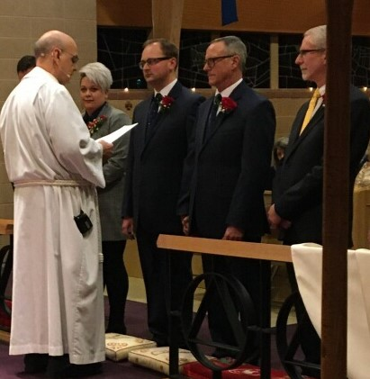
*Civil Government sees marriage as a legal contract between two parties.
*Christian marriage is not merely a contract; it is a covenant: a sacred promise that involves not only the two people being married but also God and the gathered community, a union that both echoes and reflects the union between Christ and the church.

The union of husband and wife in heart, body, and mind is intended by God for their mutual joy; for the help and comfort given one another in prosperity and adversity; and, when it is God’s will, for the procreation of children and their nurture in the knowledge and love of the Lord. Therefore, marriage is not to be entered into unadvisedly or lightly, but reverently, deliberately, and in accordance with the purposes for which God instituted it.

Marriage Inclusivity

The Episcopal Church is an affirming place for all people, regardless of sexual orientation.
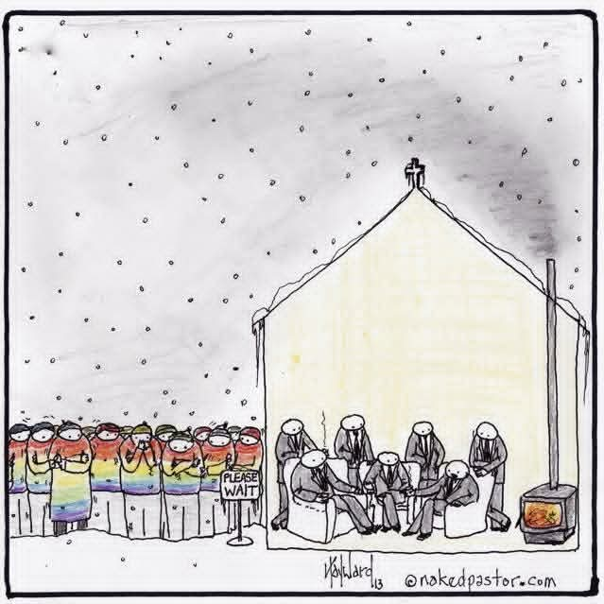
The trial Rites for same-sex marriage mirror the existing liturgies with gender references adjusted. The normative teaching of the church is that same sex marriage is legal and covenantal.

Resources:
Marriage Rites for the Whole Church: Task Force on the Study of Marriage
Beyond a Binary God: A Theology for Trans* Allies Tara K. Soughers
Queer & Christian: Reclaiming the Bible, Our Faith and Our Place at the Table Brandon Robertson

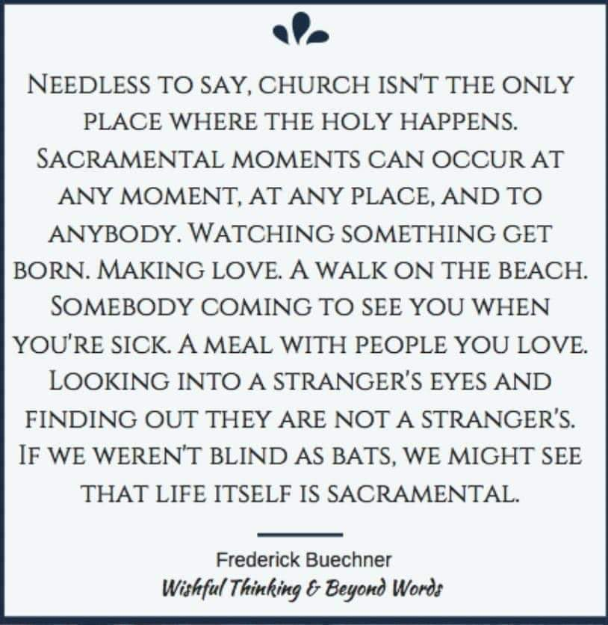
Normative Characteristics of Christian Marriage

Mutual fidelity and steadfast love reflect the union between Christ and his church.
Intended for mutual joy, help, comfort, and the nurture in the knowledge and love of the Lord.
Becoming one flesh (Sexual Intimacy in the context of a committed relationship)

Confession and Healing

Throughout the gospel narratives, Jesus heals those he encounters. His healing addresses more than bodily health; Jesus forgives sins, healing the soul. Jesus heals emotional distress. Jesus heals relationships and communities, bringing people back into reconciled life with one another and with God. Jesus is life and ministry teaches that God's desire for people is health and wholeness.

As Christians, we strive to live this ministry of healing and reconciliation by offering prayers, forgiveness, and compassion to one another. Two Sacramental rights in the Episcopal Church-reconciliation of a penitent and unction of the sick-serve as outward signs of our participation in the experience of God's reconciliation and healing.

Reconciliation of a Penitent

The Episcopal Church’s approach to the Rite of Reconciliation of a Penitent “Private Confession” is that all can, some should, none must.

Reconciliation of a penitent is not required to receive other sacraments or to be in a right relationship with God. Instead, reconciliation is an opportunity, a chance to name before God and someone else the things for which we're sorry or ashamed that burden our conscience. And then in return, we hear from God and from another person the truth that we are forgiven and loved and reconciled.

Confession
I am sorry for…….
That was wrong because…..
Next time I will…….
What can I do to help? (or How can I make this right?)
Will you forgive me?

Unction

Praying, anointing, and laying hands on the sick is a practice the church has engaged in from the earliest times until this day. The sacramental rite in which we do this is called unction, meaning simply “to anoint.” Anointing is the act of pouring or rubbing oil on a person.

Extreme Unction “Last Rite” See “Ministration at the Time of Death” Book of Common Prayer Pg. 462

Are any of you suffering? They should pray. Are you cheerful? They should sing songs of praise. Are any of you sick? They should call for the elders of the church and have them pray over them, anointing them with oil in the name of the Lord. The prayer of faith will save the sick, and the Lord will raise them up; and anyone who has committed sins will be forgiven. Therefore, confess your sins to one another, and pray for one another, so that you may be healed. The prayer of the righteous is powerful and effective.
James 5: 13-16

